WORLD’S CHILDREN DAY 20 November 2024
Smile , play, learn and grow! Wishing our ECE Classes suoerstars a happy world children’s Day ! May your childhood be a magical adventure
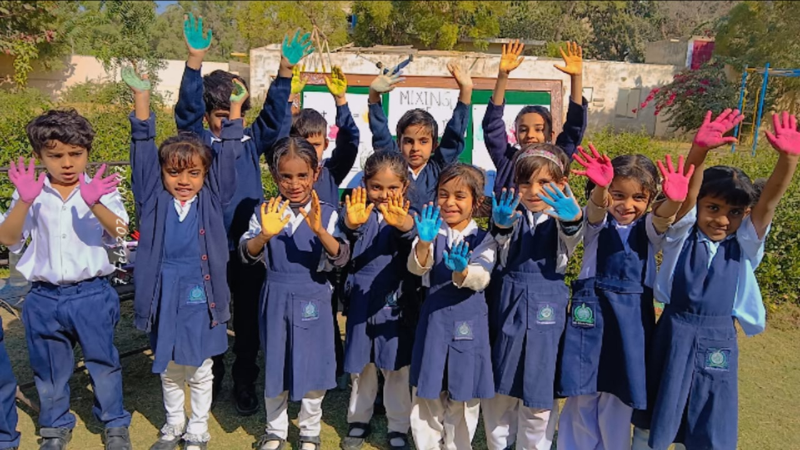
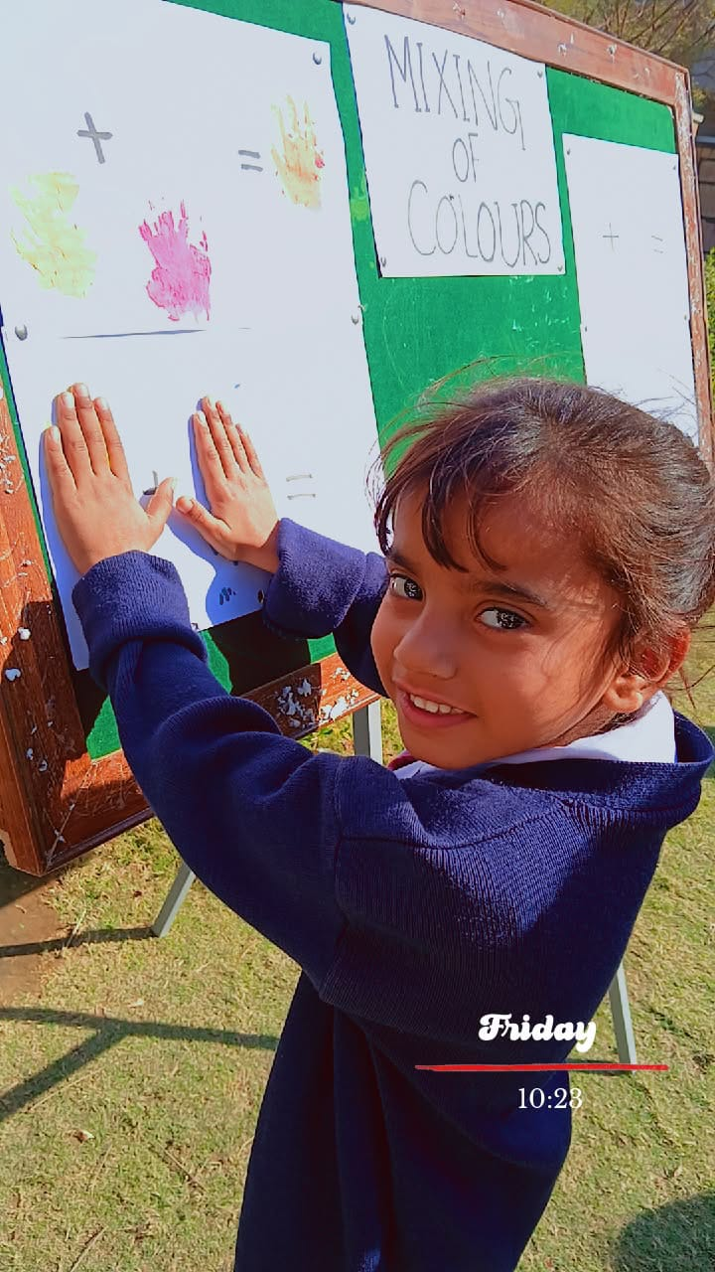
ORANGE DAY 2 December 2024
Sunshine in a colour! Happy Orange Day to Our ECE rockstars . Wishing you a day filled with art , imagination and fun!.
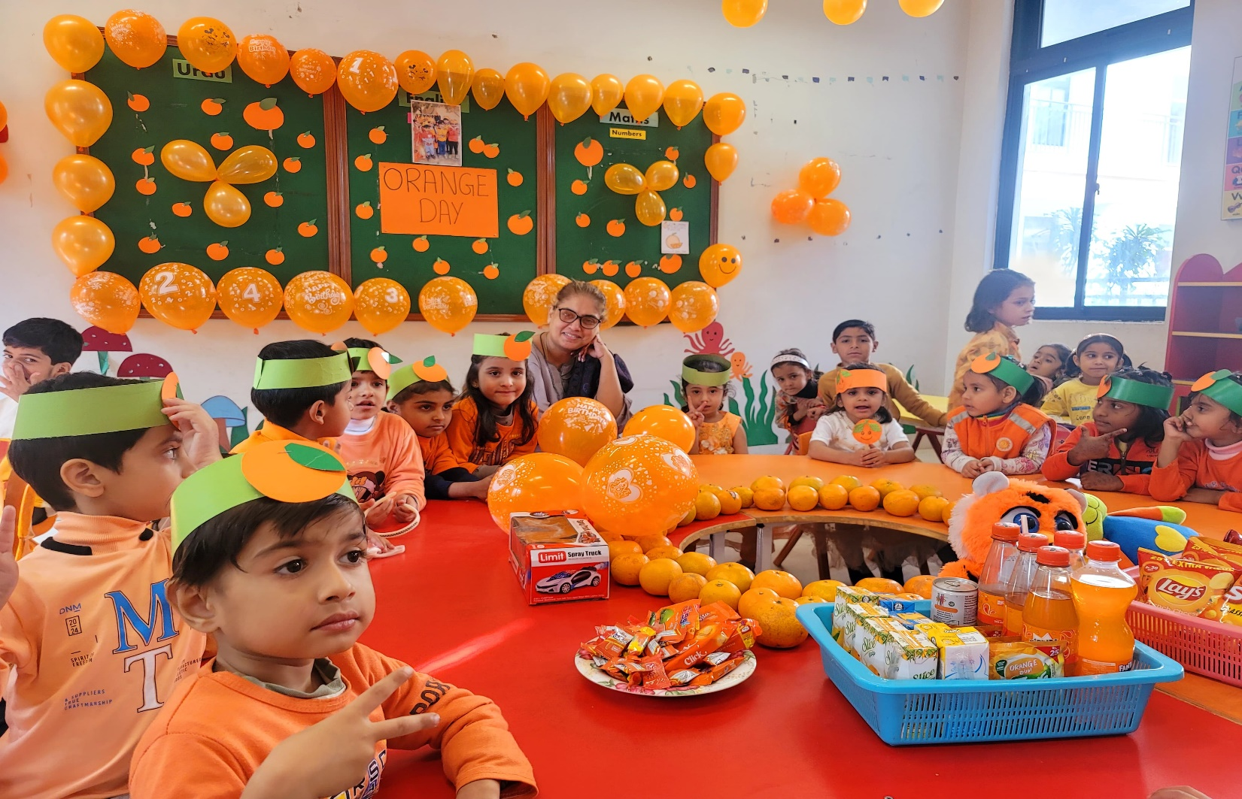
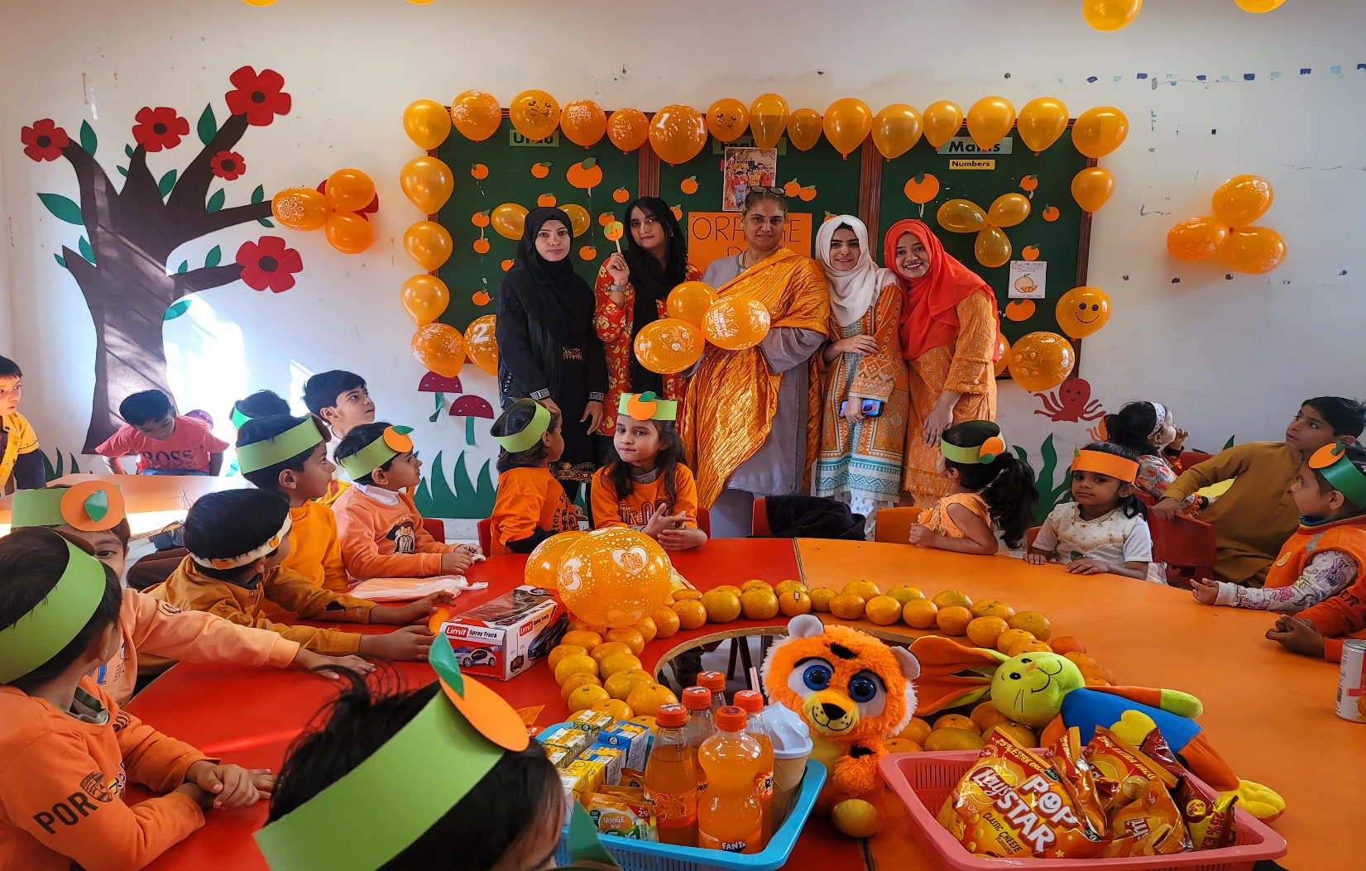

STUDENT’S AND SPORTS WEEK 16 December 2024
Sports Week is here! Classes ( 1 – 8 ) , participated in different out door games such as : Volly Ball, tennis , Racing, Sage racing , Kho Kho , Musical Chairs , Ango Mango and Batball

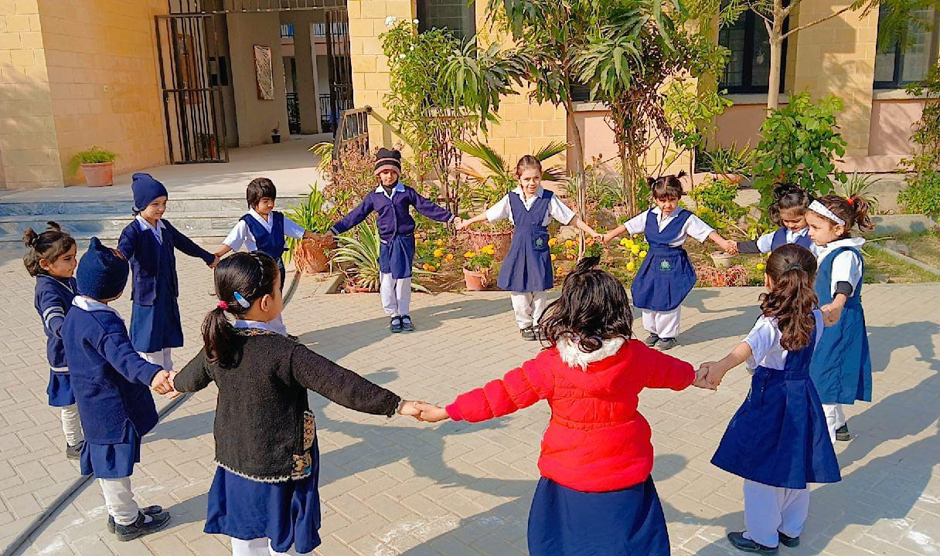
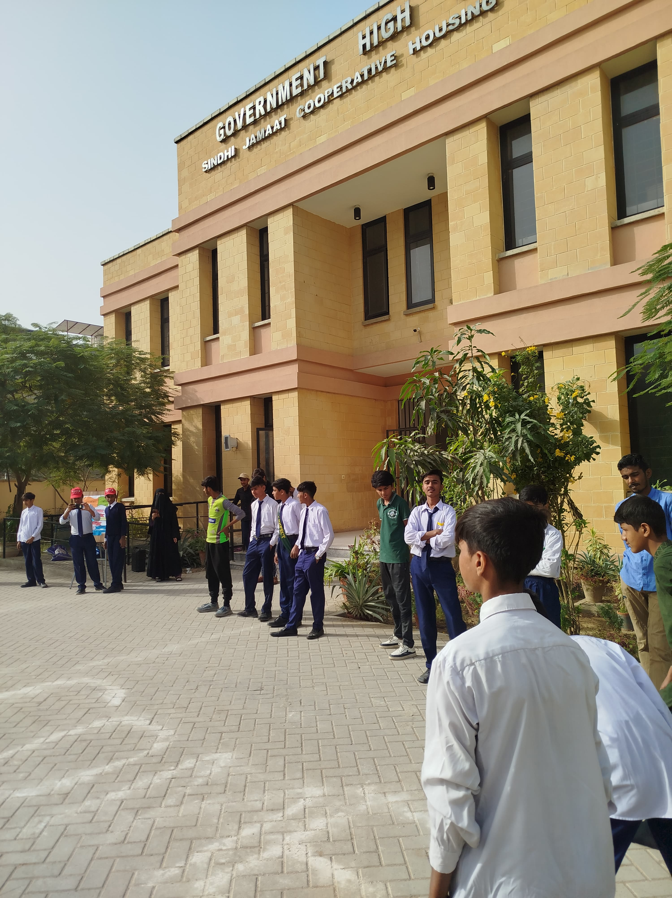

PARENT’S TEACHER MEETING 1 January 2025
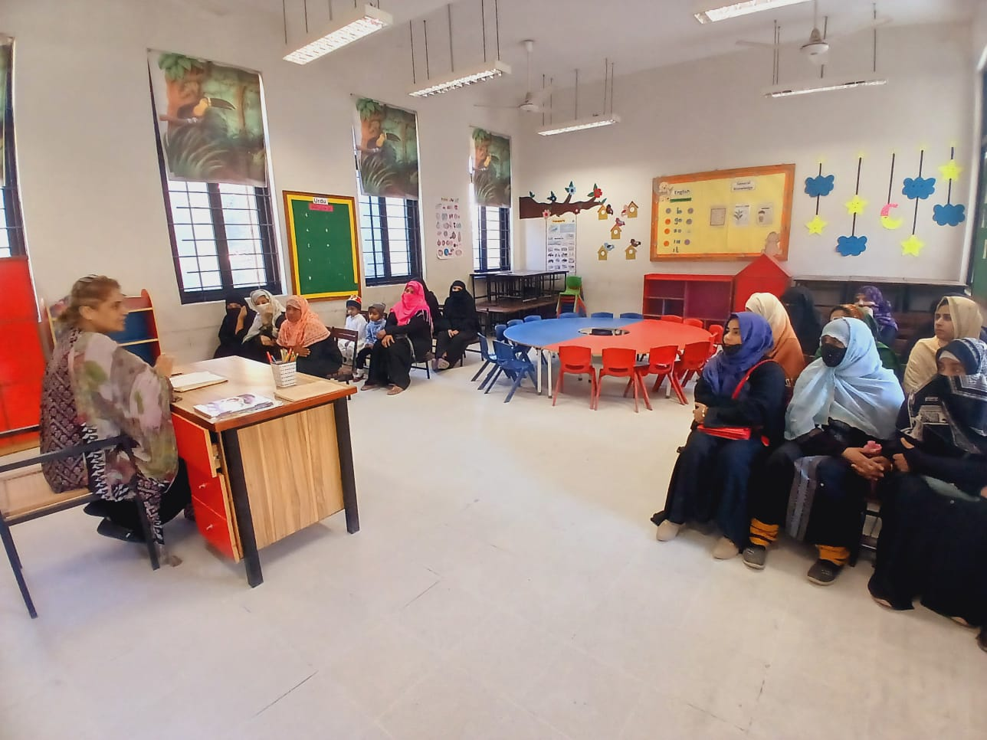
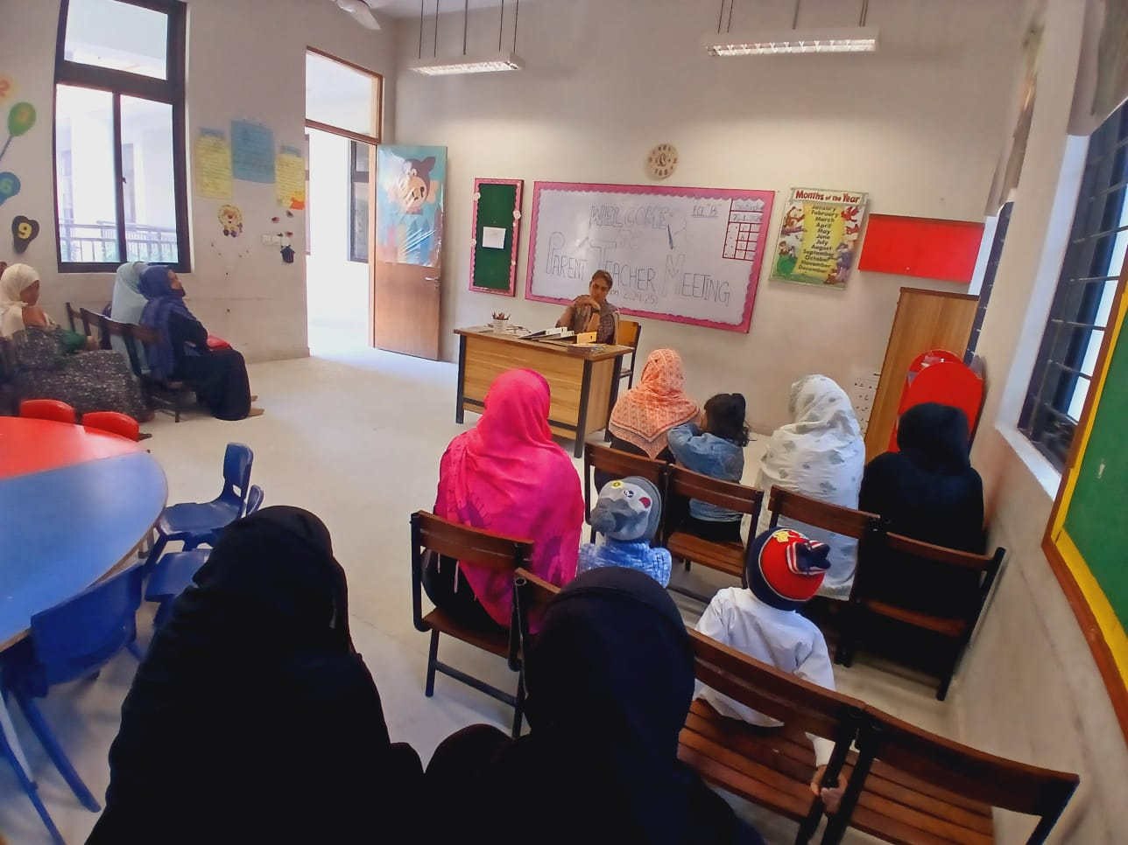
WINTER DAY CELEBRATION 17 January 2025
Frosly morning and warm smiles! ECE- level 3 enjoyed a very good winter day with joy

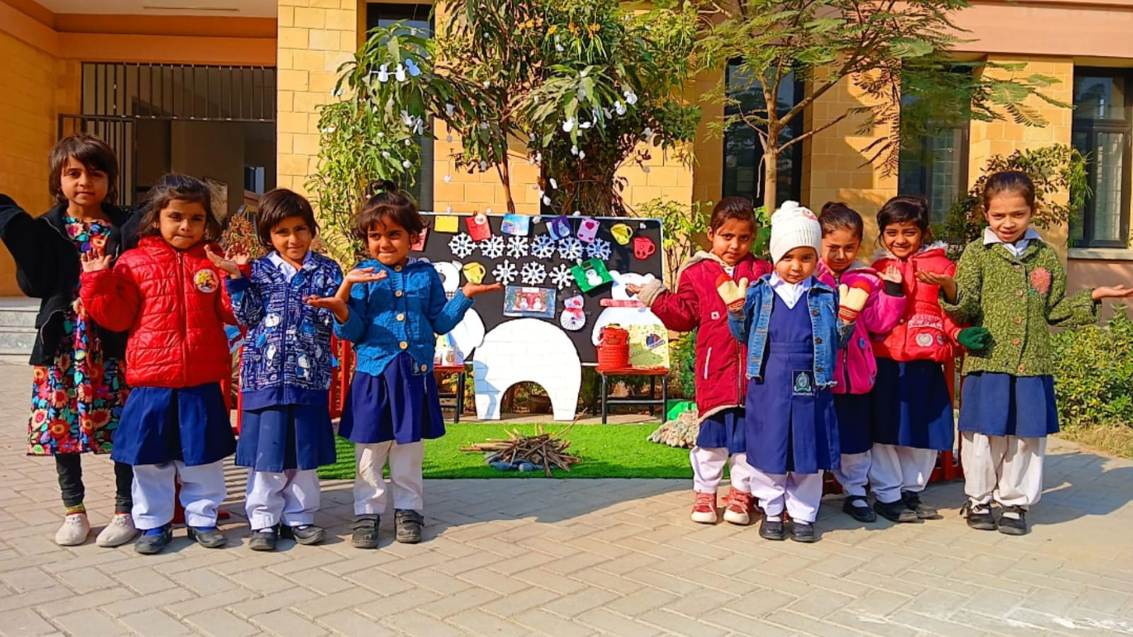
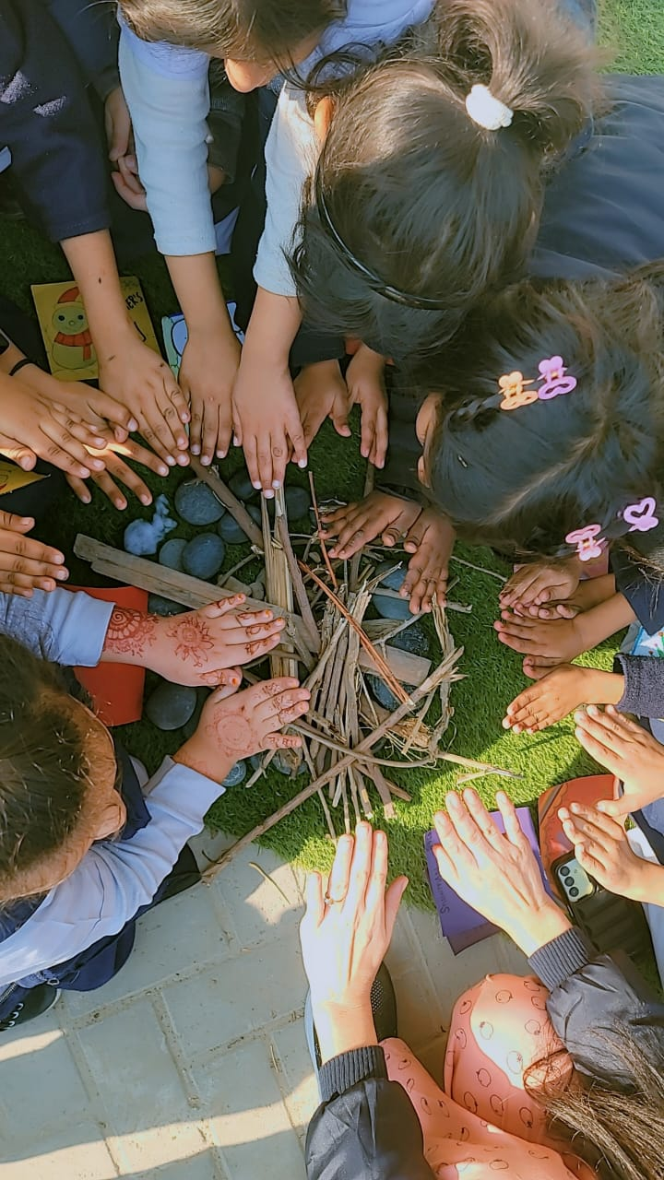

COLOURS DAY 1 February 2025
